**Assignment -1**

Python Programming

|  |  |
| --- | --- |
| Assignment Date | 19 September 2022 |
| Student Name | Mr. Saran K |
| Student Roll Number | CITC1907039 |
| Maximum Marks | 2 Marks |

**Question 1:**

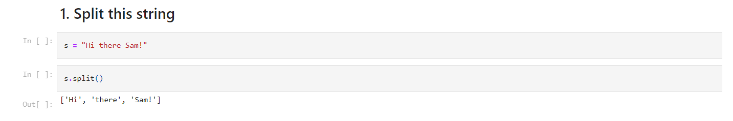

**Question 2:**

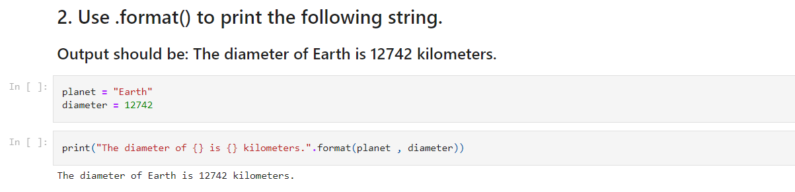

**Question 3:**

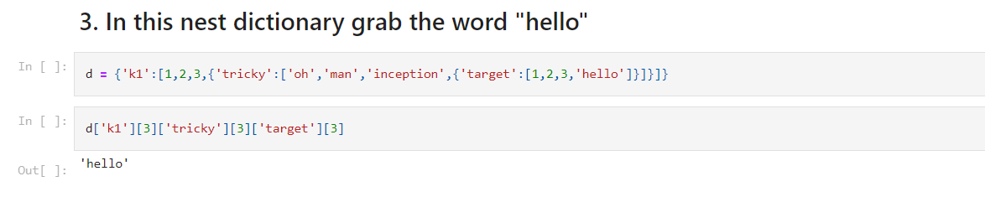

**Question 4:**

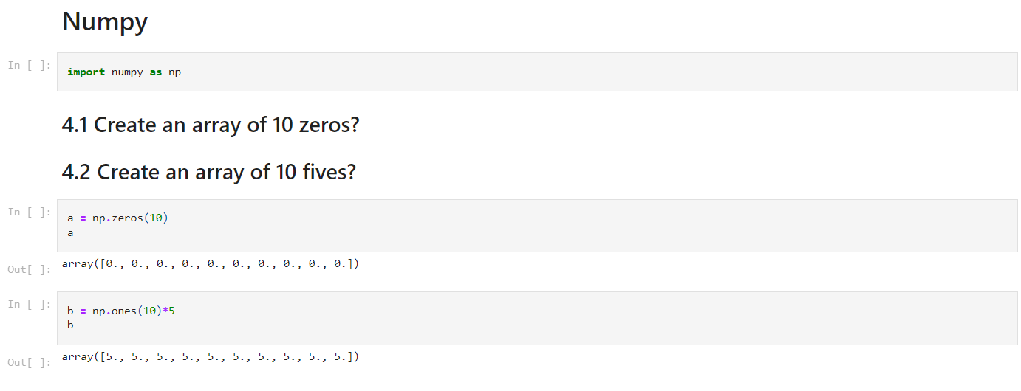

**Question 5:**

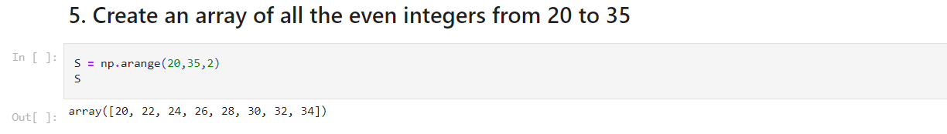

**Question 6:**

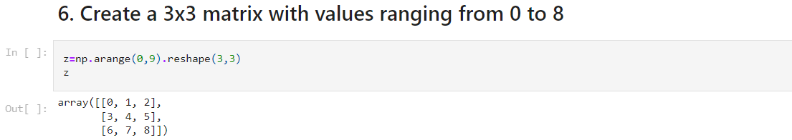

**Question 7:**

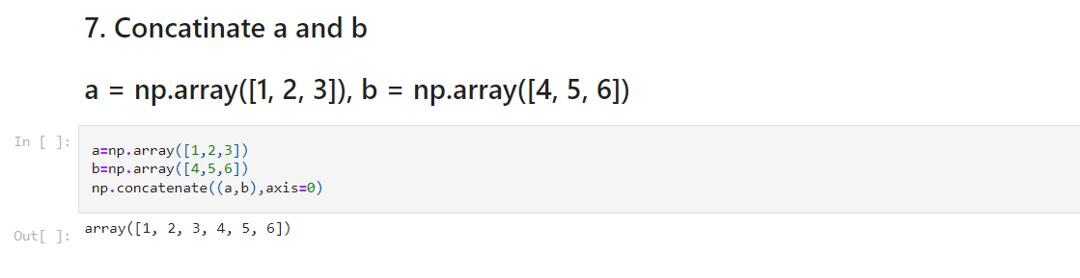

**Question 8:**

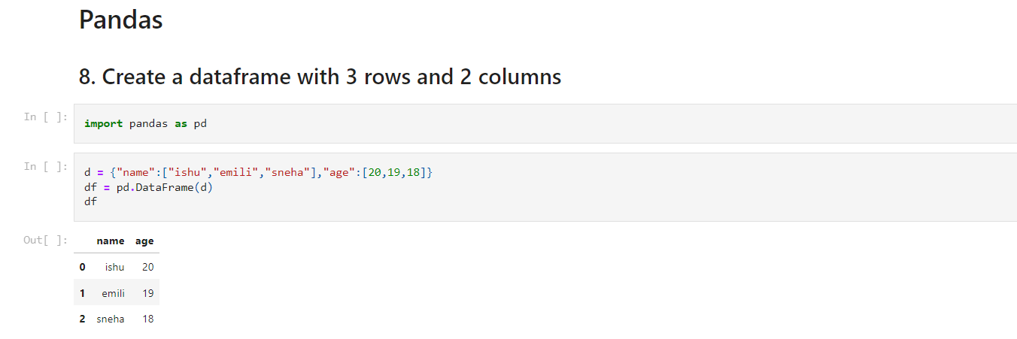

**Question 9:**

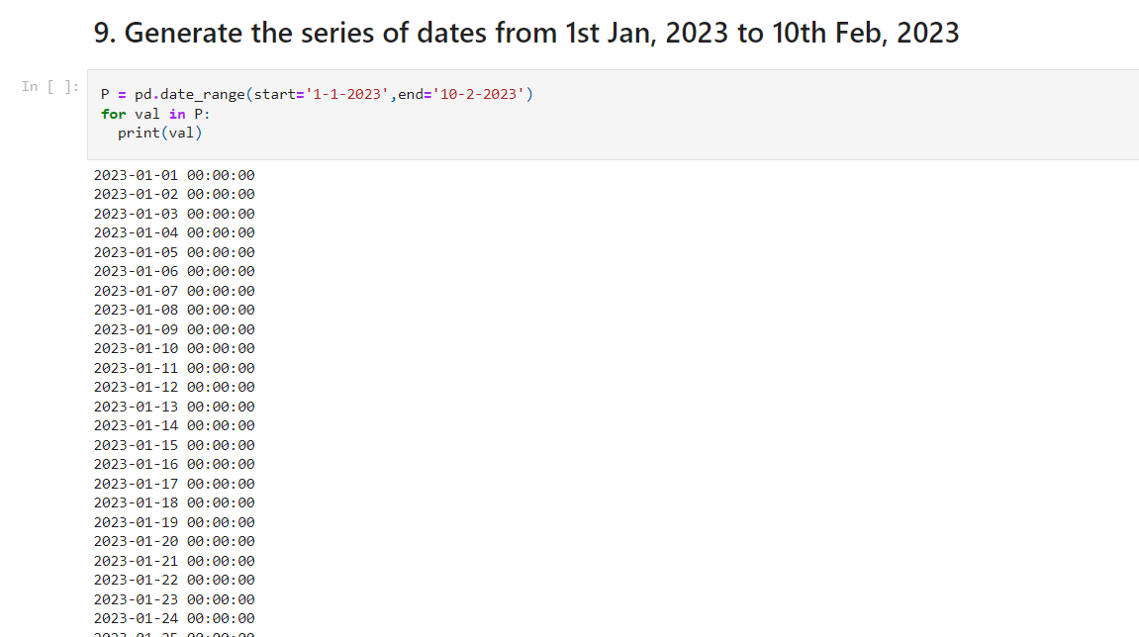

**Question 10:**

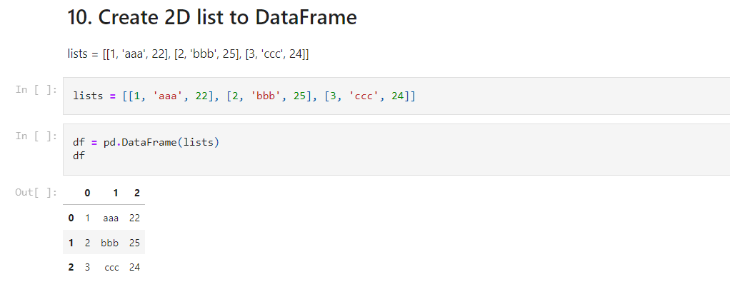**SSSS**